Press release

Trützschler Nonwovens GmbH
Halterner Str.70
D-48249 Dülmen
Press Relations Contact:
Jing Sun
Jing.Sun@truetzschler.de
+49 2594 5099-231

Geneva, Switzerland, May 20, 2026

Trützschler establishes in-depth strategic cooperation with Fujian Leo Group

The strategic cooperation signing ceremony between Trützschler and Fujian Leo Group, a Chinese customer specializing in the R&D, production and sales of personal hygiene products for ten 4.2m Air-Through-Bonding (ATB) lines was grandly held in Geneva, Switzerland. The signing marks a new milestone in the partnership. Leveraging Trützschler’s advanced nonwoven technology, Fujian Leo Group will complete a large-scale production line upgrade, further consolidate its production capacity advantages and strengthen its core competitiveness in the industry.

Trützschler first kicked off its in-depth cooperation with Fujian Leo Group in 2022 with the launch of the first 3.8m back-to-back double carding ATB line. Since its commissioning, the production line has won high recognition from Fujian Leo Group for its stable operation, outstanding production capacity and top-tier product quality, laying a solid foundation of trust for long-term strategic collaboration. Benefiting from favorable cooperation results and well-adapted equipment performance, both sides have continuously expanded the layout and built up a matrix of intelligent production lines.

Prior to this signing, Fujian Leo Group had already deployed nine 3.8m Trützschler high-speed and high-capacity ATB lines as well as one 4.2m ATB line. The stable operation of the ten professional lines has enabled Leo Group to achieve efficient and standardized production in the nonwoven materials sector. With this new round of collaboration, the two parties sealed the third-phase order for another ten 4.2m Trützschler high-speed and high-capacity ATB production lines. Once fully put into operation, Leo Group will own a total of 20 Trützschler ATB lines, forming a modern production system featured with scale, efficiency and intelligence.

The newly signed 4.2m high-speed and high-capacity ATB production line is Trützschler’s core equipment iteratively upgraded to meet market demands of the nonwoven industry. Inheriting the brand’s mature carding technology and equipped with an intelligent control system, it features a wider working width, higher productivity, lower energy consumption and uniform and stable finished product quality. It perfectly caters to large-scale production demands for high-end nonwoven materials, helping Leo Group optimize production structure, boost operational efficiency, cut production costs and expand layout in the high-end product market.

As a more than 130-year-old German family-owned enterprise, Trützschler specializes in textile machinery manufacturing, headquartered in Mönchengladbach, Germany. Its business covers three core segments: Spinning, Nonwovens and Card clothing. With multiple production bases worldwide, the company ranks among the global leaders in textile machinery industry by virtue of exquisite manufacturing craftsmanship, cutting-edge R&D technology and comprehensive after-sales service system. It keeps delivering professional, customized and intelligent complete production solutions for global partners.

A leading enterprise with remarkable scale and influence in the nonwoven industry, Fujian Leo Group has long been committed to the R&D production and sales of nonwoven materials, adhering to the philosophy of high-quality development and accurately grasping industry trends. The enterprise consistently empowers capacity upgrading with intelligent equipment. Its continuous investment in purchasing high-end Trützschler ATB production lines fully demonstrates its strategic determination to deepen the main business and scale up operations, as well as high recognition of Trützschler’s equipment quality and technical strength.

Enterprise representatives from both sides expressed high expectations for this strategic cooperation at the signing ceremony. Trützschler officials stated that Fujian Leo Group is a core strategic partner in the nonwoven sector, and the two sides have achieved mutual benefit and coordinated development over the years. Going forward, Trützschler will continue to provide high-quality equipment, professional technical support and full-cycle operation and maintenance services to ensure the efficient commissioning and operation of production lines, helping Leo Group improve quality and efficiency. Meanwhile, it will take this cooperation as an opportunity to further explore China’s nonwoven market, upgrade technological R&D and localized service capabilities, and empower more industrial enterprises with transformation and upgrading.

Leaders of Fujian Leo Group commented that Trützschler’s high-end intelligent production lines are perfectly aligned with the enterprise’s long-term development strategy. Previous collaborative lines have strongly supported Leo’s capacity expansion and quality optimization. The ten new 4.2m ATB lines will help Leo Group expand capacity and strengthen its position in the high-end nonwovens market.

The signing in Geneva, Switzerland stands as an important milestone of mutual empowerment and win-win cooperation between Trützschler and Fujian Leo Group, as well as a vivid epitome of the high-end, intelligent and large-scale development of the global nonwoven industry. Moving forward, the two sides will further deepen strategic cooperation, leverage complementary technologies and shared resources to tap into industrial potential. By delivering high-quality equipment and professional standardized production, they will drive industrial upgrading and jointly inject strong momentum into the high-quality development of the global nonwoven industry.

Photo：
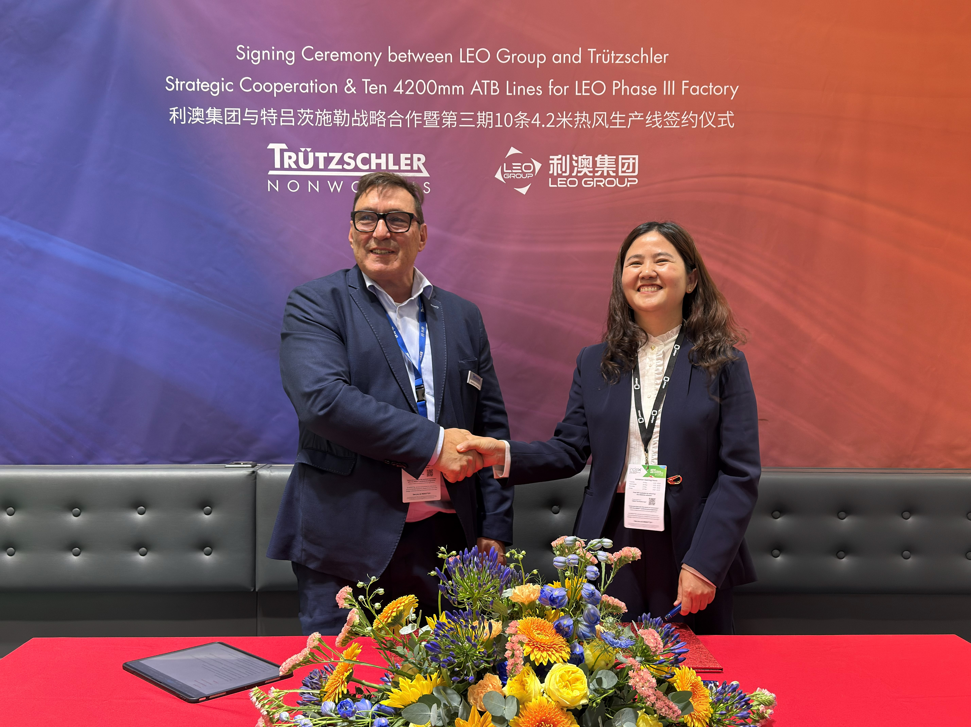
Signatories (from left to right) Mr. Matthias Schemken (Managing Director of Trützschler Nonwovens)，Mrs. MeiLing Chen (Director of Procurement of Leo Group)

Representatives of Trützschler and Fujian Leo Group at the signing ceremony (from left to right) Mr. ZhengYu Hu, (Sales of Trützschler Textile Machinery (Jiaxing) Co., Ltd.)，
Mr. WeiZhong Zhu (Sales Director of Trützschler Textile Machinery (Jiaxing) Co., Ltd.), Mr. Matthias Schemken (Managing Director of Trützschler Nonwovens), Mrs. MeiLing Chen (Director of Procurement of Leo Group), Mr. Harald Schoepp(General Manager of Trützschler China), Mr. Weiping Zhang (Vice General Manager of Truetzschler Textile Machinery (Jiaxing) Co., Ltd.)

About the Trützschler Group:

The Trützschler Group SE is a German textile machinery manufacturer headquartered in Mönchengladbach, Germany. The company is divided into three business units: Spinning, Nonwovens and Card Clothing. Trützschler Spinning is the global technology and market leader in spinning preparation in the cotton and man-made fiber sector. With TRUECYCLED, Trützschler Spinning offers a complete solution in spinning preparation for state-of-the-art recycling of textile waste – from opening and cleaning to carding and drawing secondary fibers, resulting in high-quality, sustainable yarns. Trützschler Card Clothing is the global market leader in the production of high-performance card clothing for cards and roller cards. Trützschler Nonwovens is a leading supplier of complete production lines and machinery for needle-punched, hydroentangled (spunlaced), through-air and chemical bonded nonwovens. Trützschler machines, installations and accessories are produced and developed in nine locations worldwide. This includes four factories in Germany (Dülmen, Egelsbach, Mönchengladbach, Neubulach), as well as sites in China (Jiaxing and Shanghai), India (Sanand), the USA (Charlotte) and Brazil (Curitiba). Local service companies in Türkiye, Mexico, Uzbekistan and Vietnam and local service teams in Pakistan, Bangladesh and Indonesia provide customer proximity in key regions for the textile processing industry. For more information visit: www.truetzschler.com

